1. SELECT obat.id, nama_obat, dimunim, no_telp

FROM `obat`

JOIN merek_obat ON obat.id_obat = merek_obat.id

ORDER BY nama_obat ASC

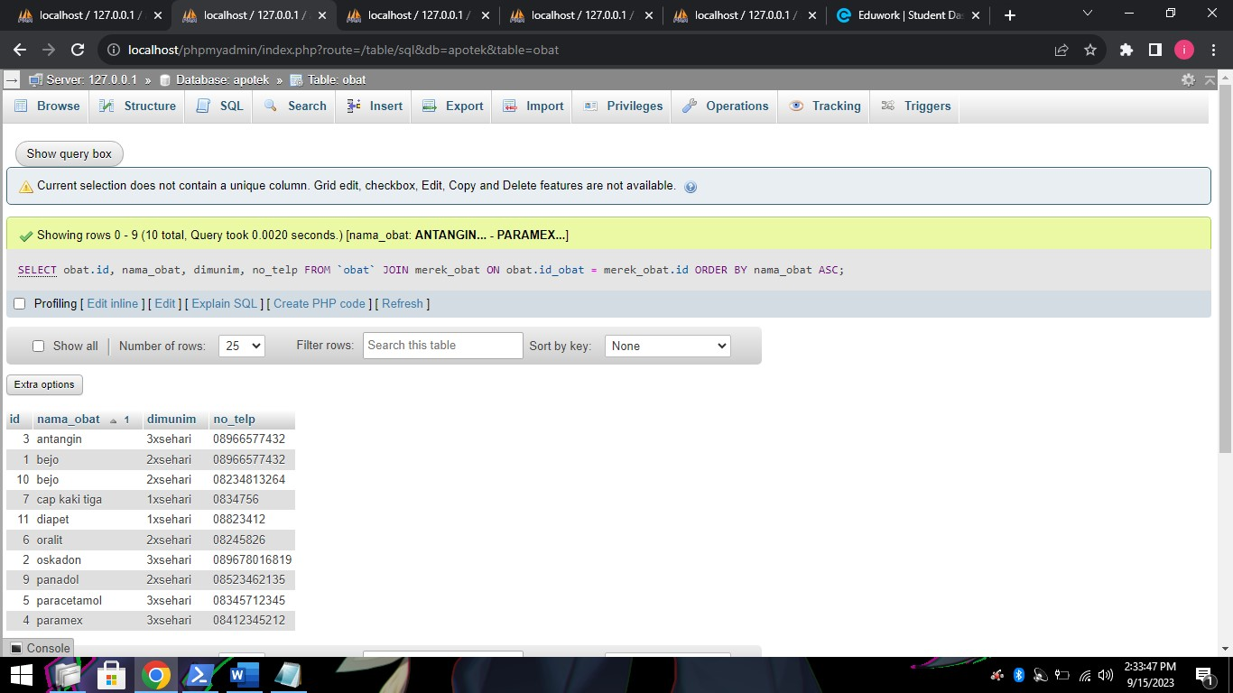

1. SELECT nama_obat, kadarluarsa, tanggal_datang

FROM obat

JOIN merek_obat ON obat.id = merek_obat.id

ORDER BY kadarluarsa ASC

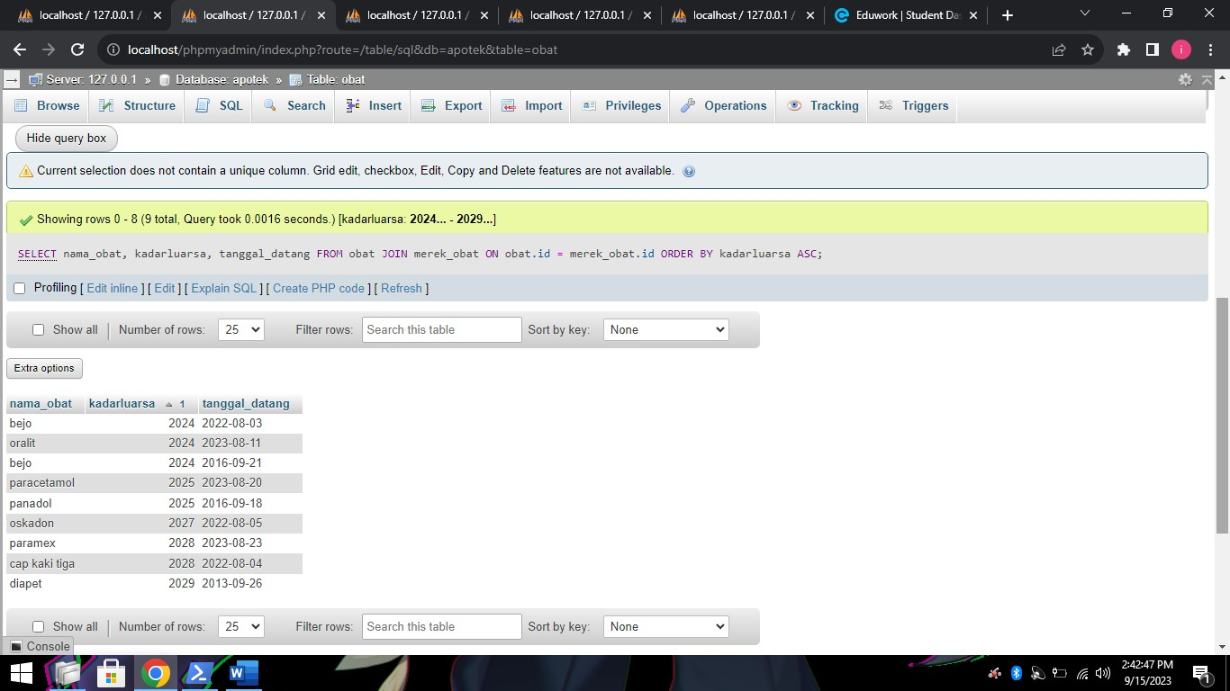

1. SELECT nama_obat, kadarluarsa, tanggal_datang

FROM obat

LEFT JOIN merek_obat ON obat.id = merek_obat.id

ORDER BY kadarluarsa ASC

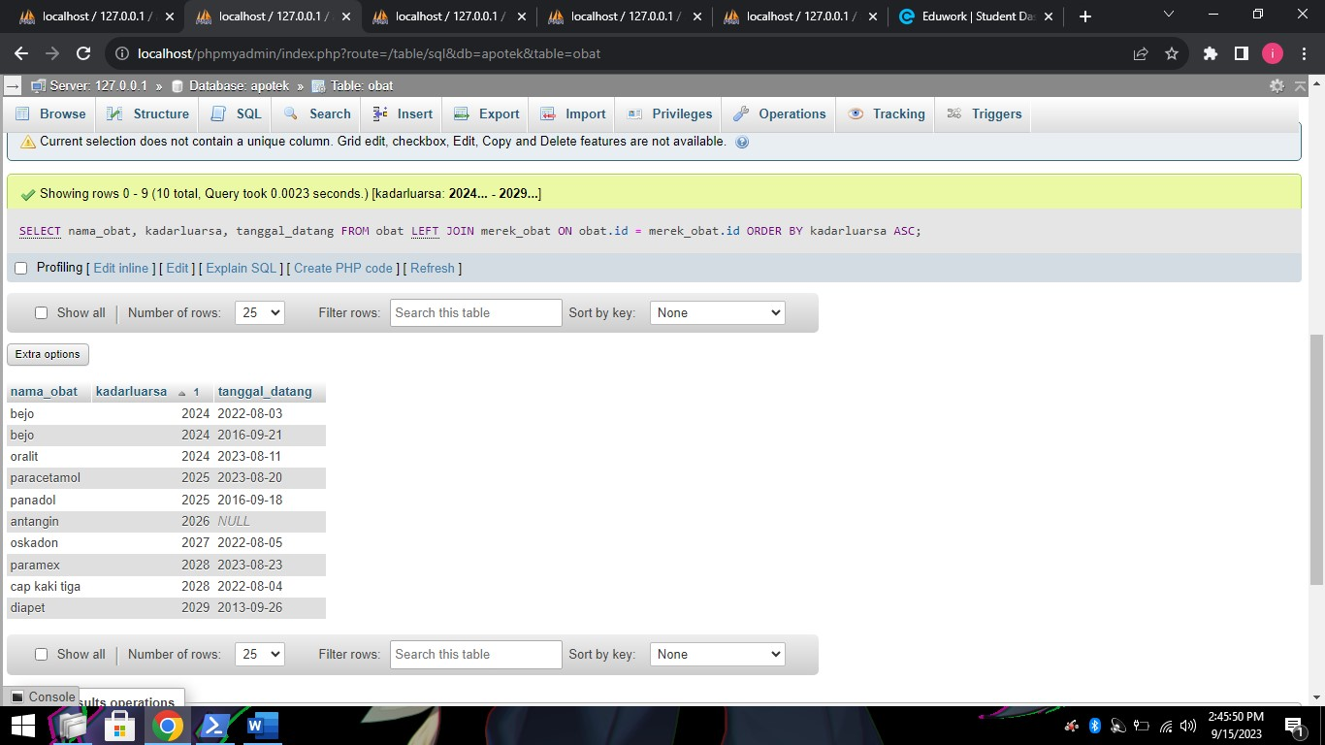

1. SELECT obat.id, nama_obat, dimunim, no_telp

FROM `obat`

RIGHT JOIN merek_obat ON obat.id_obat = merek_obat.id

ORDER BY nama_obat ASC

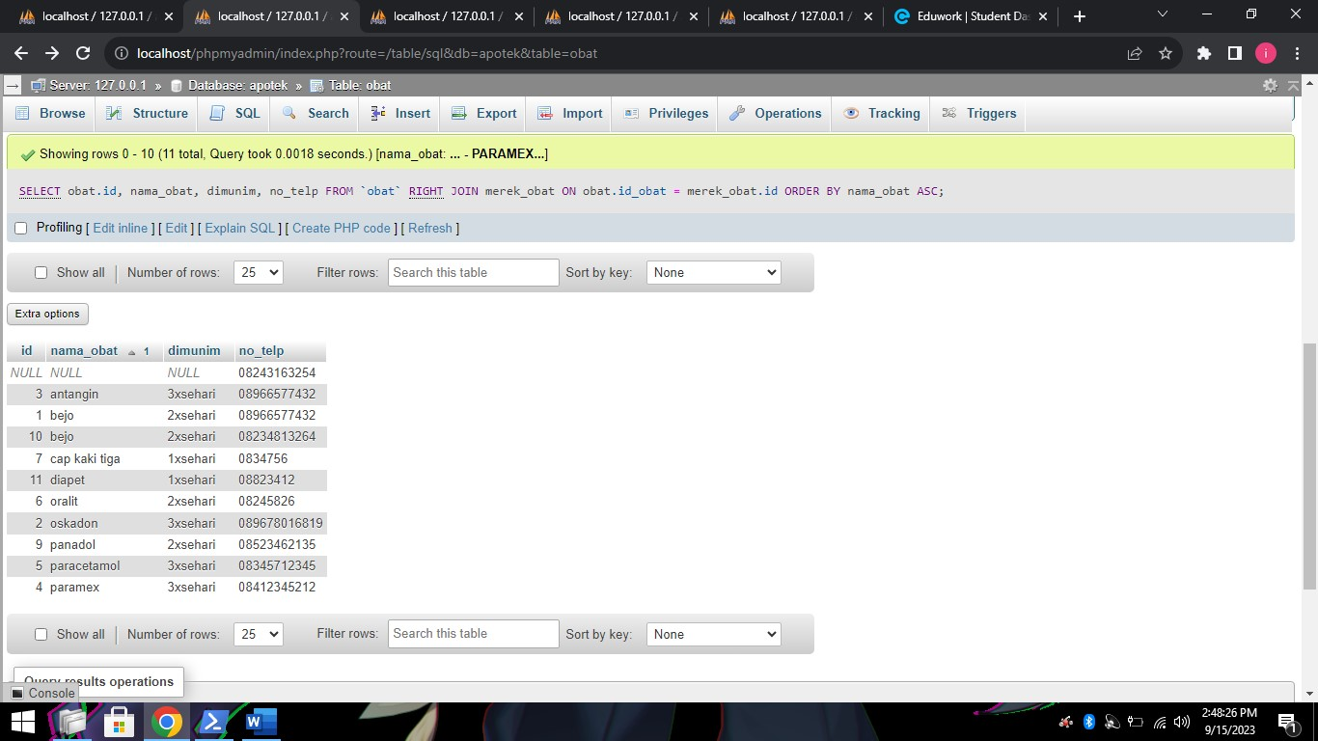

1. SELECT obat.id, nama_obat, dimunim, no_telp

FROM `obat`

RIGHT JOIN merek_obat ON obat.id_obat = merek_obat.id

WHERE keterangan_obat LIKE '%pusing%'

ORDER BY nama_obat ASC

